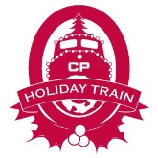
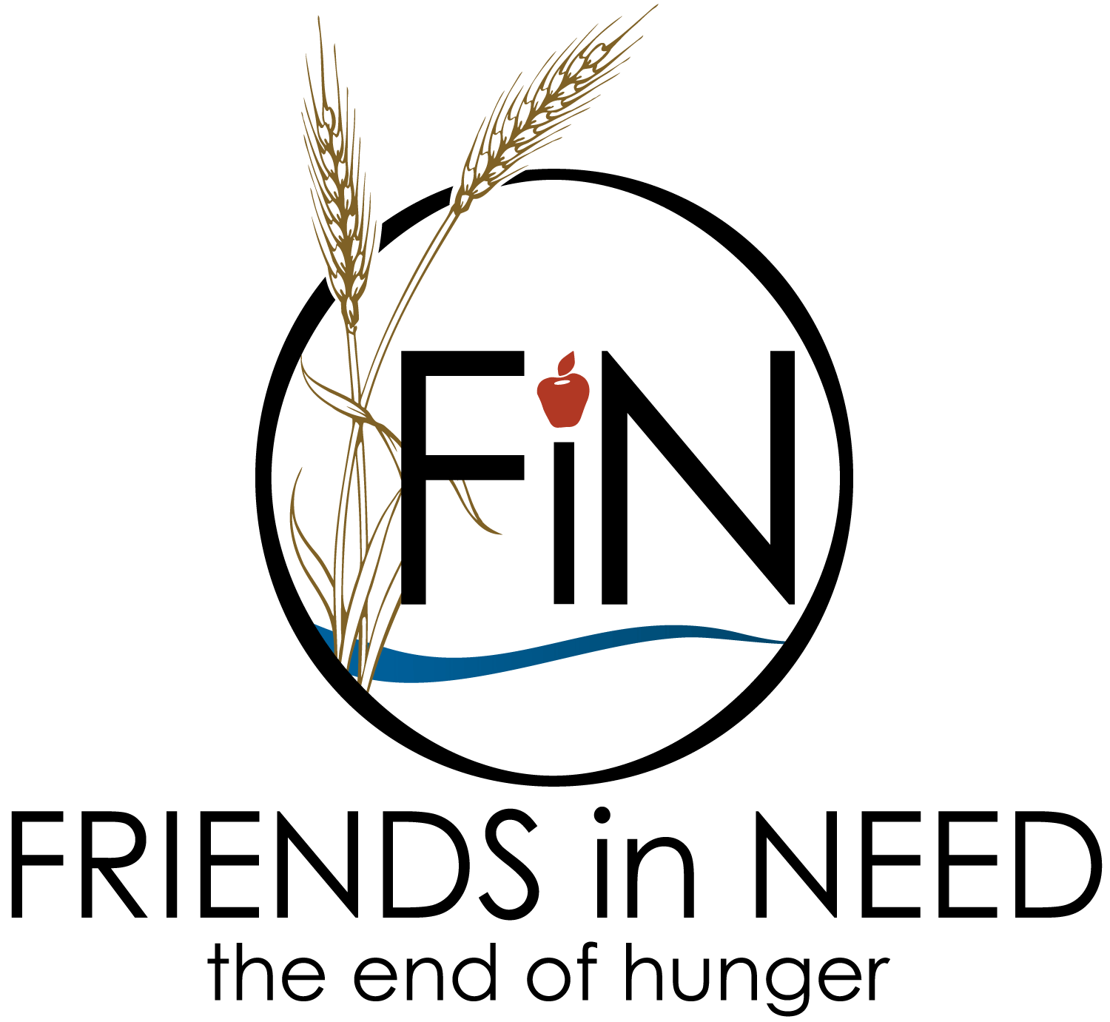
We Invite You to Get Involved in the 20th Anniversary of the
Canadian Pacific Holiday Train,
Cottage Grove Area

DATE: Monday, December 12, 2022
TIME: 5:00 p.m. Arrival

Come early to enjoy the delicious food and beverages, stop in the warming tent and shop for Holiday Train merchandise!

Location is at West Point Douglas Road, just south of the 80th St. Bridge / Belden Crossing
(across from the Youth Service Bureau)

Our goal is to raise $90,000 in 2022 for Friends in Need Food Shelf

Become a Name Sponsor or Participate in Pre-Stop Fundraising Events

Collect Cash or Personal Care Items at
Your Business or Organization
Attend Fill Up A Fire Truck  Saturday, December 3, Noon – 2 p.m.  We will be accepting Toilet Paper, Paper Towels & Cash. (No Food Items Please) | Donate items or a basket for  Virtual Silent Auction by November 14  Bring to RE/MAX Professionals: 7420 80th Street S. #201, Cottage Grove or contact Chelsea Swaggert to  arrange for pick-up.

Questions &/OR Participate: Contact the Holiday Train Committee Co-Chairs
Randy Bachman, RFBachman@merchantsbank.com, (651) 438-7385 or
Chelsea Swaggert, chelsea.swaggert@yahoo.com, (952) 240-3793

Please see the attached Sponsorship Packages and details on “How to Participate”

Sincerely,
Holiday Train Committee 2022 | in cooperation with the cities of
Supporting the Friends in Need Food Shelf | Cottage Grove, Newport, St. Paul Park and the
501(c)3 # 41-1794212 | Cottage Grove Area Chamber of Commerce

Sponsorship Packages

All Aboard Sponsor ($10,000+)
- Opportunity to present check on Van Meter Truck Stage at Holiday Train Event
- (2) Designated Parking Spots at Event
- Logo on Thank You Ad in the Cottage Grove Journal
- Name on 2022 Donor Wall Plaque at FIN Food Shelf
- Logo on FIN Website
- Thank you on Holiday Train – Cottage Grove Stop Facebook Page
- Logo on Banner at Event
- (4) Pair of Holiday Train Flannel PJ Pants

Golden Spike Sponsor ($5000+)
- Opportunity to present check on Van Meter Truck Stage at Holiday Train Event
- (1) Designated Parking Spot at Event
- Logo on Thank You Ad in the Cottage Grove Journal
- Name on 2022 Donor Wall Plaque at FIN Food Shelf
- Logo on FIN Website
- Thank you on Holiday Train – Cottage Grove Stop Facebook Page
- Logo on Banner at Event
- (2) Pair of Holiday Train Flannel PJ Pants

Silver Spike Sponsor ($1000+)
- Opportunity to present check on Van Meter Truck Stage at Holiday Train Event
- Name on Thank You Ad in the Cottage Grove Journal
- Logo on FIN Website
- Name on 2022 Donor Wall Plaque at FIN Food Shelf
- Thank you on Holiday Train – Cottage Grove Stop Facebook Page
- Name on Banner at Event
- (1) Pair of Holiday Train Flannel PJ Pants

Bronze Spike Sponsor ($500+)
- Opportunity to present check on Van Meter Truck Stage at Holiday Train Event
- Name on Thank You Ad in the Cottage Grove Journal
- Name on FIN Website
- Name on 2022 Donor Wall Plaque at FIN Food Shelf
- Thank you on Holiday Train – Cottage Grove Stop Facebook Page
- Name on Banner at Event

Little Engine That Could Sponsor - contributes in-kind support with pre-stop fundraising or volunteers or logistics
- Name on Thank You Ad in the Cottage Grove Journal
- Name on FIN Website
- Thank you on Holiday Train Facebook Page

How to be a Sponsor - Send a check to the Friends in Need Food Shelf, P.O. Box 6, Cottage Grove, MN 55016. Please note “Holiday Train” in the memo line. Questions or to pledge a donation, please contact the Holiday Train Committee Chair, Randy Bachman: rfbachman@merchantsbank.com

How to Participate in the Pre-Stop Fundraisers and Other Opportunities – details available on our Facebook Page at www.facebook.com/pg/CottageGroveHolidayTrain or contact the Holiday Train Committee Co-Chairs.

All cash and personal care item donations collected at our “Stop” go directly to our local Friends in Need Food Shelf; serving the residents of Cottage Grove, Grey Cloud Island, Newport and St. Paul Park.

