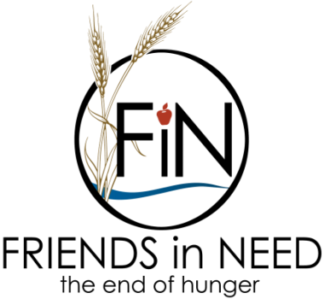 | Stocks, Bonds or Mutual Funds Transfer Form

Please follow these steps to notify the Friends in Need Food Shelf of your donation:
- Contact your broker to initiate the transfer of your securities to the Friends in Need Food Shelf.
- Please complete this form at the time of the gift transfer so we can accurately identify, allocate and acknowledge your gift.
Mail this form to: Or email to: Director@finfood.org
Friends in Need Food Shelf
Michelle Rageth. Director
P. O. Box 6
Cottage Grove, MN 55016

Donor Information:

Your Name

Address

City, State Zip Code

Phone

Email

Securities Gifted:

Number of shares

Name of securities

Date of transfer
Fund designation | Friends in Need General Fund Other (Please Specify):

Transferring broker

Company

Phone

Electronic Transfer Information
Our Broker: Securities America Inc., 12325 Port Grace Blvd., LaVista, NE 68128
DTC#: 0443 (clearing through Pershing LLC)
Friends in Need Account #: 73U349591
Friends in Need Tax ID# (TIN): 41-1794212
Broker Contact: John L. Anderson, (651)438-7377, janderson@merchantsinvest.com

Thanks so much for your support!

